

**Module Title**

**Second Year Project**

**Assessment Weightage & Type**

**Second Year Project Final Report**

**Year and Semester**

**2023/24 Autumn**

**Student Name: Aayush Wanem Limbu**

**College ID: np05cp4a220010**

**London Met ID: 22072043**

**Assignment Due Date:**

**Assignment Submission Date:**

**Supervisor Name:**

**Title: ThreatGuard**

*I confirm that I understand my coursework needs to be submitted online via My Second Teacher under the relevant module page before the deadline in order for my assignment to be accepted and marked. I am fully aware that late submissions will be treated as non-submission and a mark of zero will be awarded.*

# **Introduction**

# 1.1 Project Description

ThreatGuard is a web-based Intrusion Detection System (IDS) designed to simplify server management and safety for system administrators and network administrators. This IDS system is built using modern tools and technologies to ensure robustness, fault tolerance, security, and efficiency in handling large amounts of data. The email alert system ensures quick notification of security incidents, helping administrators respond swiftly. This proactive approach enhances security and minimizes the impact of cyber-attacks, setting a new standard in host device security.

## 1.2 Current Scenario

Intrusion Detection System(IDS) and Machine Learning. In today's rapidly evolving digital landscape, the proliferation of network connectivity has brought about a corresponding increase in cybersecurity threats. Intrusion Detection Systems (IDS) play a pivotal role in safeguarding networks by monitoring and analyzing network traffic to detect and respond to malicious activities. However, traditional IDS face significant challenges in effectively identifying and mitigating modern, sophisticated attacks. Traditional IDS, such as Snort and Suricata, typically rely on predefined rules or signatures to detect known threats. For example, Snort uses a signature-based approach to compare network traffic against a database of known attack patterns. Similarly, Suricata utilizes signature-based detection along with support for protocol analysis and anomaly-based detection to identify suspicious activity. However, these signature-based approaches have limitations when faced with unknown or evolving attack vectors. For instance, a zero-day exploit, which exploits a vulnerability that is unknown to the software vendor, may bypass signature-based detection, leading to a successful attack. Additionally, signature-based IDS can generate a high number of false positives if the signatures are too broad or if they match legitimate traffic patterns. Moreover, traditional IDS often struggle to distinguish between legitimate and malicious activity, leading to false positives. For example, legitimate activities such as network scans or software updates may trigger alerts in an IDS if they are not properly configured to differentiate between normal and suspicious behavior. The increasing complexity and volume of network traffic pose scalability challenges for traditional IDS. As network traffic grows, IDS may struggle to keep pace with the volume of data, leading to performance issues and potential missed detections. To address these limitations, there has been a growing interest in leveraging machine learning algorithms for intrusion detection. Machine learning offers the potential to enhance IDS capabilities by enabling systems to learn from and adapt to new threats in real-time. By analyzing patterns and anomalies in network traffic data, machine learning algorithms can detect subtle signs of malicious activity that may go unnoticed by traditional IDS.

However, the deployment of machine learning-based IDS presents its own set of challenges. These include the need for large, labeled datasets for training, the complexity of algorithm selection and tuning, and the risk of adversarial attacks designed to deceive machine learning models. Considering these challenges, there is a pressing need for research to evaluate the effectiveness of machine learning algorithms in enhancing IDS accuracy and efficiency. By exploring the capabilities of algorithms such as decision trees, KNN, and the random forest classifier, researchers seek to improve the detection capabilities of IDS and strengthen network security in the face of evolving cyber threats.

## 1.3 Problem Domain and Project as a Solution

**Problem Domain:**

The rapid evolution and increasing sophistication of cyber threats pose significant challenges to traditional intrusion detection systems (IDS). Signature-based IDS, which rely on predefined patterns to detect attacks, often struggle to keep pace with the constantly evolving tactics used by attackers. This leads to high false positive rates and missed detections, leaving networks vulnerable to various forms of cyber-attacks, including malware infections, denial-of-service attacks, and data breaches.

Additionally, the sheer volume and complexity of network traffic make it challenging for IDS to efficiently analyze and identify malicious behavior in real-time. This is further compounded by the increasing use of encryption and other obfuscation techniques by attackers to evade detection.

**Project as a Solution:**

To address these challenges, our project proposes the development of an IDS that leverages machine learning algorithms to enhance its detection capabilities. By using machine learning, our IDS can analyze large datasets, identify patterns indicative of malicious activity, and adapt to new threats in real-time. This approach allows for more intelligent and dynamic threat detection, leading to improved detection accuracy and reduced false positives.

One of the key innovations of our project is the integration of machine learning algorithms, specifically the Random Forest Classifier, into the IDS. This integration enables the IDS to continuously learn from new data, refine its detection models, and adapt to emerging threats. Additionally, our IDS will utilize the KDDCUP99 dataset, a benchmark dataset for intrusion detection, to train and test the machine learning algorithms, ensuring the system's effectiveness against a wide range of intrusion scenarios.

Overall, our project aims to provide a robust and efficient IDS solution that can enhance cybersecurity measures by detecting and mitigating various network attacks in real-time. By leveraging machine learning algorithms, we aim to address the limitations of traditional IDS and contribute to the advancement of intrusion detection technology.

## 1.4 Aims and Objectives

**Aims:**

The primary aim of this project is to develop a robust and efficient Intrusion DetectionSystem (IDS) capable of identifying and mitigating various network attacks. This project aims to enhance cybersecurity measures by implementing advanced machine learning algorithms and integrating them into a comprehensive IDS.

**Objectives:**

**Develop an Intrusion Detection System:**

Create a functional IDS that can monitor network activities, detect suspicious patterns, and identify potential intrusions.

**Implement Machine Learning Algorithms:**

Utilize machine learning algorithms, specifically the Random Forest Classifier, to enhance the IDS&#39;s accuracy in identifying network attacks and distinguishing them fromnormal network traffic.

**Integration of Frontend and Backend Technologies:**

Integrate frontend technologies (HTML, CSS, JavaScript) to create an intuitive user interface and backend technologies (Django) to handle data processing and algorithm implementation.

**Utilize KDDCUP99 Dataset:**

To utilize the KDDCUP99 dataset, a benchmark dataset for intrusion detection, to train and test the machine learning algorithms, ensuring the system&#39;s effectiveness against a wide range of intrusion scenarios.

**Optimize System Performance:**

Optimize the system&#39;s performance by selecting appropriate hardware components, including processors, memory, and storage, ensuring seamless execution of algorithms and efficient data processing.

**Implement Virtualization:**

Implement virtualization techniques to create a scalable and flexible environment, allowing for the deployment and testing of the IDS in various configurations.

**User-Friendly Interface:**

Develop an intuitive user interface that allows administrators to visualize detected

intrusions, generate reports, and configure the IDS settings, ensuring ease of use and accessibility.

**Testing and Validation:**

Conduct rigorous testing, including unit testing, integration testing, and performance testing, to validate the IDS&#39;s accuracy, efficiency, and reliability under different network conditions and attack scenarios.

By achieving these objectives, the project aims to deliver an advanced and user-friendly intrusion Detection System, contributing significantly to the realm of cybersecurity and network protection.

## 1.5 Structure of the Report

**1.5.1 Background**

The background section encompasses research on similar projects and includes comparisons among various systems. It also gathers information about the end users of the system. The section briefly explains the system architecture and provides a comprehensive list of required functions and features. Additionally, it details the tools and technologies that will be utilized during the development phase.

**1.5.2 Development**

The development phase of the project involves implementing the core functionality of the Intrusion Detection System (IDS), integrating machine learning algorithms such as the Random Forest Classifier, designing a user-friendly interface, and conducting thorough testing and validation. The IDS will be designed to monitor network activity, detect suspicious patterns, and provide real-time alerts to administrators. By leveraging machine learning, the system aims to improve detection accuracy and adaptability to emerging threats. Documentation, deployment, and ongoing maintenance and support are also key aspects of the development process to ensure the system's effectiveness and reliability in enhancing cybersecurity measures.

**1.5.3 Testing and Analysis**

Testing and analysis are crucial phases in the project, ensuring the Intrusion Detection System (IDS) functions effectively and meets requirements. Testing includes unit, integration, system, user acceptance, performance, and security testing. Analysis involves evaluating machine learning algorithm effectiveness, alert accuracy, performance metrics, and user feedback. Through rigorous testing and analysis, the project aims to deliver a reliable and efficient IDS.

**1.5.4 Conclusion**

The report is finally concluded in this section of the report. In this section, legal issues, social issues and ethical issues of the project are also discussed including the advantages, limitations and future plan of the project.

# **Background**

The "Background" section provides essential context for the project, including the problem domain, related work, motivation, objectives, scope, technologies, and project team. It sets the stage for the rest of the report, highlighting the project's significance and goals.

## 2.1 End user

This project will only have one type of enduser which is the administrator. This project is a small CRUD project in which there is the machine learning model, the network capture model and the django web application. The admins will get notifications via email when there is a attack detected. The admin can add another users and they would get their username and password via the email that they are registered at. The admins can view the system status such as ram and cpu usage and what ports are available on the local server and what services are running on them.

**2.2 System Architecture**

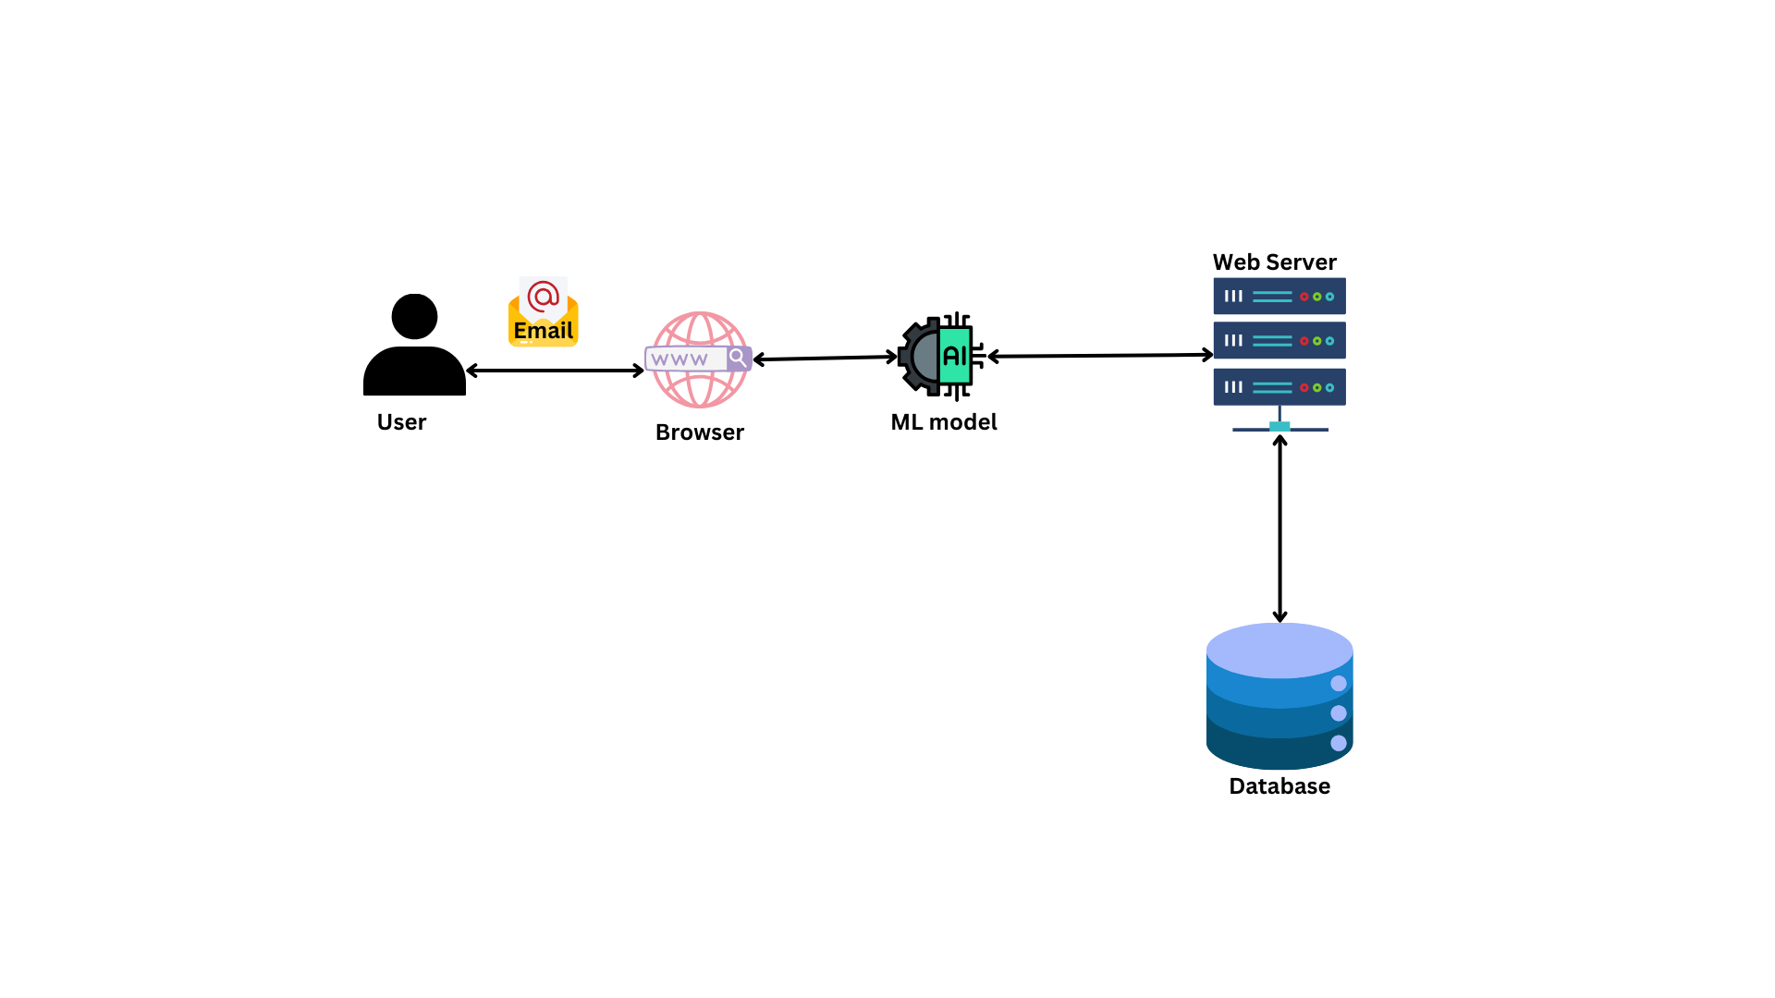

The system consists of a web server, a machine learning model and the networek capture model. The admin will be able to login to the system and see all the system information as wll as the number of open ports. The packet capture module will capture all the network packets and send information to the machine learning model for predriction.

## 2.3 Functions and Features

The functions and features of the system are as follows:

1. Authentication
2. User registration
3. See and record cpu and ram usage
4. Identify any network attack or not
5. Dashboard Overview:
6. Update user details
7. Alert administrator at the case of an attack
8. Get the ip address and hostname

## 2.4 Review of Technical Aspects

1. Html, css and Js:

The use of HTML, CSS, and JavaScript in this project is essential for creating a user-friendly and interactive web interface. HTML provides the structure of the web pages, CSS is used for styling and layout, and JavaScript adds interactivity and dynamic behavior to the pages.

1. Django:

Django is a powerful web framework for building web applications in Python. It provides a clean and pragmatic design, making it easy to build and maintain complex web applications. In this project, Django is used to handle user authentication, CRUD operations, and communication with other components of the system.

1. Sqlite3:

SQLite is a lightweight, serverless, and self-contained SQL database engine. It is the default database engine used by Django for development and testing purposes. In this project, SQLite will be the primary database, providing a simple and efficient way to store and retrieve data for the intrusion detection and notification system.

1. Random Forest Classifier:

Random Forest is a machine learning algorithm that uses an ensemble of decision trees to make predictions. It is commonly used for classification tasks and is known for its robustness and high accuracy.

1. Python:

Python will be used for filtering packets and formatting captured data in this project. Python's versatility and ease of use make it well-suited for tasks such as packet manipulation and data formatting. By leveraging Python, the project can efficiently process network traffic data and extract relevant information for analysis by the machine learning model.

# Development

## 3.1 Selected Methodology

For this project, I have decided to utilize the Rational Unified Process (RUP) as the selected methodology. RUP is a comprehensive software development methodology that emphasizes iterative development, collaboration, and risk management. It divides the development process into four distinct phases: inception, elaboration, construction, and transition. Each phase is characterized by specific objectives and activities, such as defining the project scope, refining requirements, developing the system, and deploying it to users. RUP also emphasizes the importance of iterations, allowing for continuous refinement and improvement of the software. Given the complexity of the project and the need for flexibility in responding to changing requirements, RUP provides a structured and disciplined approach to software development, making it an ideal choice for this project.

## 3.2 Phases of RUP methodology

My project plan according to this methodology is described below:

* **Inception**

The Inception phase is the first phase of the RUP methodology, where the project’s feasibility and scope are assessed. During this phase, the project’s objectives, initial requirements, stakeholders, and potential risks are identified. The goal is to establish a clear understanding of the project&#39;s purpose and to justify its initiation. In this step of my project, I will be focusing on the following things which are mentioned below:

* Resource gathering
* Project planning
* Risk management
* **Elaboration**

The Elaboration phase is the second phase of the RUP methodology, focusing on detailed planning and risk mitigation. In this phase, detailed requirements are gathered, architectural foundations are established, and major risks are addressed. The goal is to refine the project vision, establish a stable architecture, and create a solid foundation for development. In this step for my project, I will be doing the following:

* Analyzing the problem domain
* Development of the use case diagram and ERD
* Analyzing the functional and nonfunctional developments
* Wireframe design and development

**• Construction**

The Construction phase is the third phase of the RUP methodology, where the actual development of the software takes place. During this phase, the software is incrementally built, features are implemented, and components are integrated. The focus is on iterative development, ensuring that the software is functional, reliable, and feature complete. In this construction step I will be doing the following:

* Dataset Cleaning
* Machine learning model development
* Real time packet analysis module development
* Frontend development
* Backend development
* Database integration

**• Transition**

The Transition phase is the final phase of the RUP methodology, involving the deployment of the software to end-users. In this phase, the software undergoes user acceptance testing, deployment planning is finalized, end-users are trained, and ongoing support mechanisms are established. The goal is to transition the software from development to production, ensuring a smooth deployment and operationalcontinuity. In this step I will be doing the following steps:

* Integration and system testing
* Real world attacks and attacks prediction
* Documentation
* Ongoing system Monitoring and performance
* Deployment

## 3.3 Software Requirement Specification(SRS)

The Software Requirements Document (SRD) is a comprehensive document that outlines the functional and non-functional requirements of a software project. It serves as a blueprint for the development team, describing in detail the system's purpose, features, and functionality. The SRD includes a detailed description of the user requirements, specifying what actions users should be able to perform and how the system should respond. It also outlines any constraints or limitations that may impact the development process. Additionally, the SRD serves as a communication tool between stakeholders, ensuring that all parties have a clear understanding of the project's scope and objectives. By documenting the requirements in the SRD, the development team can create a software solution that meets the needs of the users and aligns with the project's goals.

**Functional Requirements**

Functional requirements describe the specific behaviors and functions of a software system. They outline what the system should do in terms of inputs, outputs, and processing. These requirements are typically detailed and specific, providing a clear guide for developers to follow during implementation. Functional requirements can include features such as user authentication, data validation, calculations, and reporting. They are often written using a formal language or notation to ensure clarity and precision. Overall, functional requirements define the core functionality of the software system and are essential for ensuring that it meets the needs of its users.

The identified functional requirements for my system are:

**1. Monitor Host Devices**

* The system shall monitor network traffic on host devices.
* The system shall analyze network traffic patterns for suspicious activity.

**2 Detect Intrusions**

* The system shall use machine learning (ML) algorithms to detect intrusions.
* The system shall classify detected intrusions based on severity.

**3 Alert Administrator**

* The system shall provide alerts to administrators when intrusions are detected.
* The system shall send alerts via email.

**4 View and Administer Host Devices**

* Administrators shall be able to view a list of host devices.
* Administrators shall be able to change the status of ports on host devices.
* Administrators shall be able to view and manage services running on host devices.

**5 User Authentication**

* The system shall require users to authenticate using a username and password.
* The system shall provide a registration process for new users.

**6 User Management**

* Administrators shall be able to add new users to the system.
* Administrators shall be able to deactivate or delete user accounts.

**7 System Status Monitoring**

* Administrators shall be able to monitor the system's status, including RAM and CPU usage.
* Administrators shall be able to view available ports on the local server.
* Administrators shall be able to view services running on the local server.

These functional requirements outline the core features and capabilities of the system, providing a clear guide for development and ensuring that the system meets the needs of its users.

**Non functional requirements**

Non-functional requirements describe the attributes of a system that are not related to its specific functionality but are important for its overall operation. Here are the non-functional requirements for the system:

**Accuracy**

* The system shall be able to accurately predict and classify network intrusions based on the analysis of network traffic patterns.
* The system shall have a high level of accuracy in detecting intrusions and distinguishing them from normal network traffic.

**Performance**

* The system shall be able to process and analyze network traffic data in real-time.
* The system shall be able to handle a high volume of network traffic without significant performance degradation.

**Reliability**

* The system shall be reliable, with a low probability of false positives or false negatives in intrusion detection.
* The system shall have a backup and recovery mechanism in case of system failure.

**Scalability**

* The system shall be scalable, able to accommodate an increasing number of host devices and users.
* The system shall be able to handle a larger volume of network traffic as the system grows.

**Security**

* The system shall use encryption to protect sensitive data, such as user credentials and network traffic data.
* The system shall have measures in place to prevent unauthorized access and ensure data integrity.

**Usability**

* The system shall have a user-friendly interface that is easy to navigate and understand.
* The system shall provide clear and concise alerts and notifications to administrators.

**Compatibility**

* The system shall be compatible with a wide range of operating systems and browsers.
* The system shall be able to integrate with existing network infrastructure and security systems.

These non-functional requirements ensure that the system is not only functional but also performs reliably, securely, and efficiently, meeting the needs of its users.

**Hardware Requirements**

**• Processor:** Multi-core processor (e.g., Intel Core i5, AMD Ryzen 5) for efficient multitasking and computation.

**• Memory (RAM):** Minimum 8 GB RAM (preferably 16 GB) for smooth performance, especially with large datasets and complex algorithms.

**• Storage:** Solid State Drive (SSD) for faster data access and overall system

responsiveness.

**• Graphics Card:** (Optional) Dedicated GPU (NVIDIA GeForce or AMD Radeon) with CUDA cores or stream processors for GPU-accelerated tasks in machine learning.

**• Network:** Standard Ethernet port for stable internet connectivity.

**• Operating System:** Compatible with your chosen software tools (Windows or Linux distributions like Ubuntu, Fedora, etc.).

**• Virtualization Support:** If using virtual machines extensively, ensure the CPU supports hardware virtualization (Intel VT-x or AMD-V technology) for optimal virtualization performance.

**Software Requirements**

**• IDE:** Visual Studio Code and Sublime Text 4 for coding the backend part, jupyter-lab, Jupyter-notebook for the development of machine learning model.

**• Version Control:** GitHub

**• Frontend language:** HTML, CSS and Java Script

**• Backend language:** Django

**• Database:** Sqlite3(Django’s default)

**• Draw.io:** for UML diagrams

**• Team Gantt:** for Gantt chart

**• Figma:** for UI design and wireframe

**• Python:** for training and developing Machine Learning model

**• Machine Learning algorithm:** Random Forest Classifier

**• Dataset:** kddcup99 dataset

**• Wireshark, TCPdump, Scapy, pcapy:** for packet capture

**• Any hypervisor software:** to run the ids server in a virtual machine.

**• Windows or any Linux iso file:** to create a new virtual machine.

## 3.4 Design

Developing the design before the construction of the system is a standard practice in software development. This approach helps in understanding the system's features and workflow, simplifying the development process. The design phase allows developers to plan the system's architecture, components, and interfaces, providing a clear roadmap for implementation. This clarity ensures that developers are consistent in their approach and reduces the risk of errors or rework later in the development process. Overall, starting with a well-defined design improves efficiency, reduces risks, and leads to a more successful development process.

**Use case diagram**

Use case diagrams are visual representations of the interactions between users (actors) and a system to achieve specific goals (use cases). They illustrate the system's functionality from a user's perspective, showing how users interact with the system to accomplish tasks. Use case diagrams help in understanding the system's behavior and requirements, aiding in the design and development process.

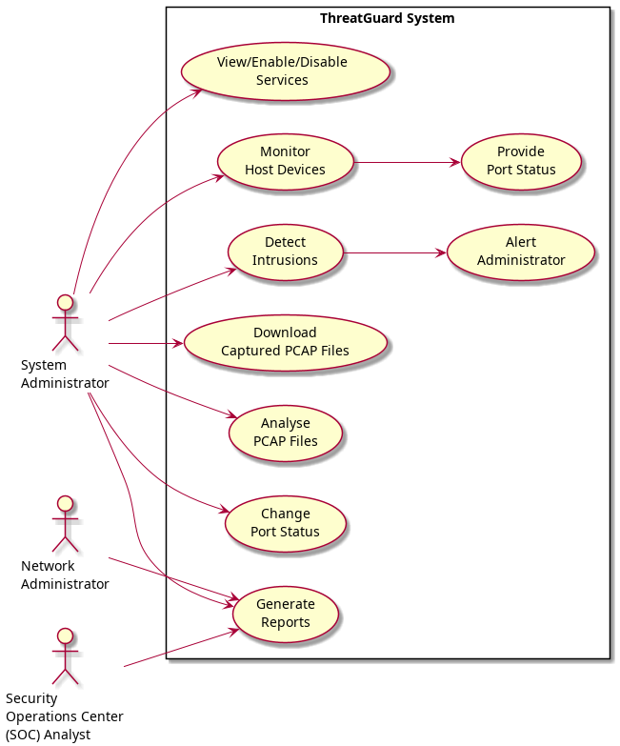

# Er Diagram

Entity-Relationship (ER) diagrams are used to model the data and relationships within a system. They show the entities (such as tables in a database), their attributes, and the relationships between entities. ER diagrams are crucial for database design as they help in visualizing the database structure and ensuring that it meets the requirements of the system.

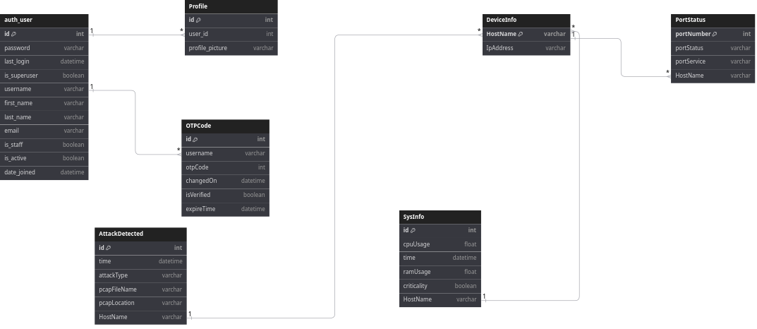

**Wireframe**A wireframe is a visual representation of a website, app, or software interface. It outlines the basic structure and layout of the interface, showing the placement of elements such as navigation menus, buttons, and content areas. Wireframes are used in the early stages of design to plan and communicate the layout and functionality of a digital product. They are typically simple and lack detailed design elements, focusing instead on the overall structure and organization of the interface.

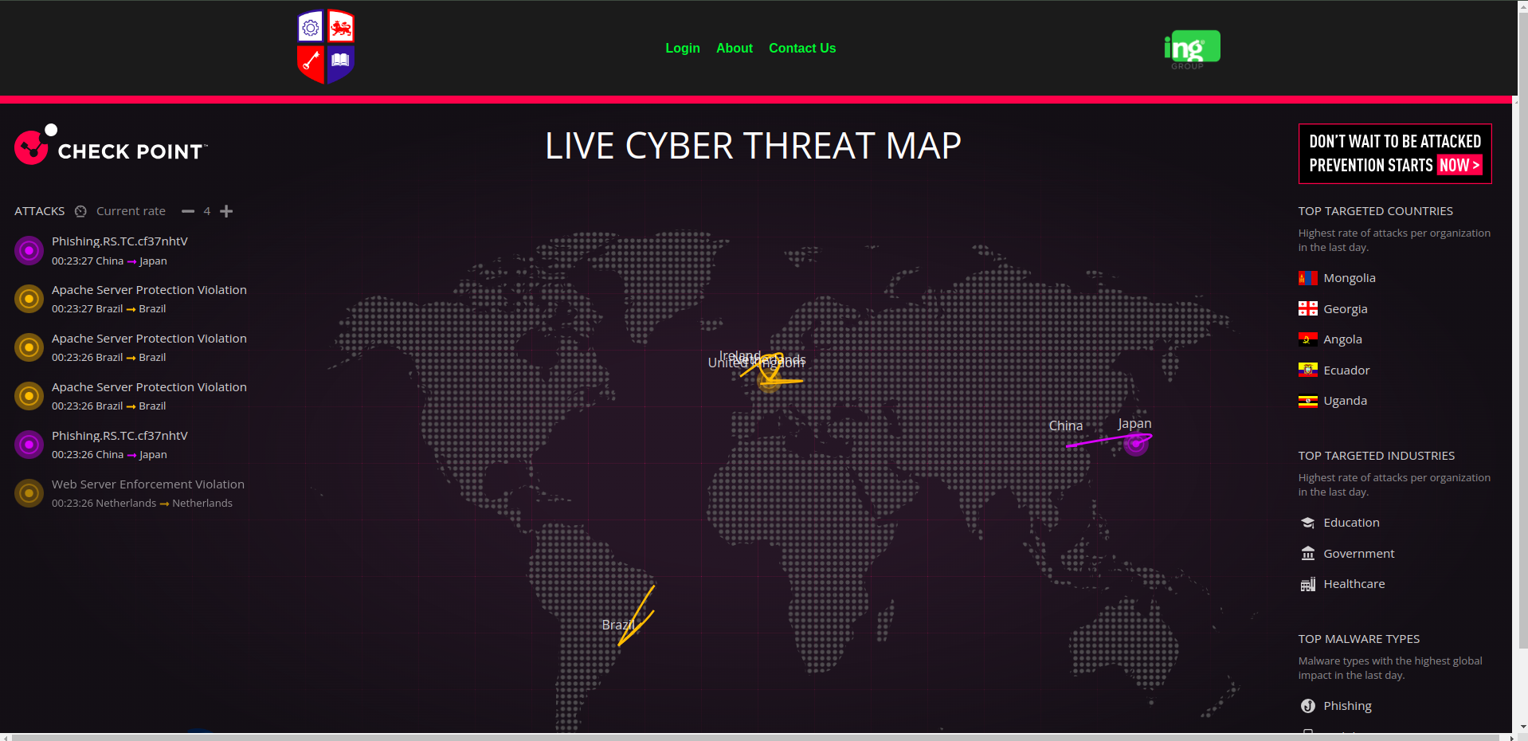

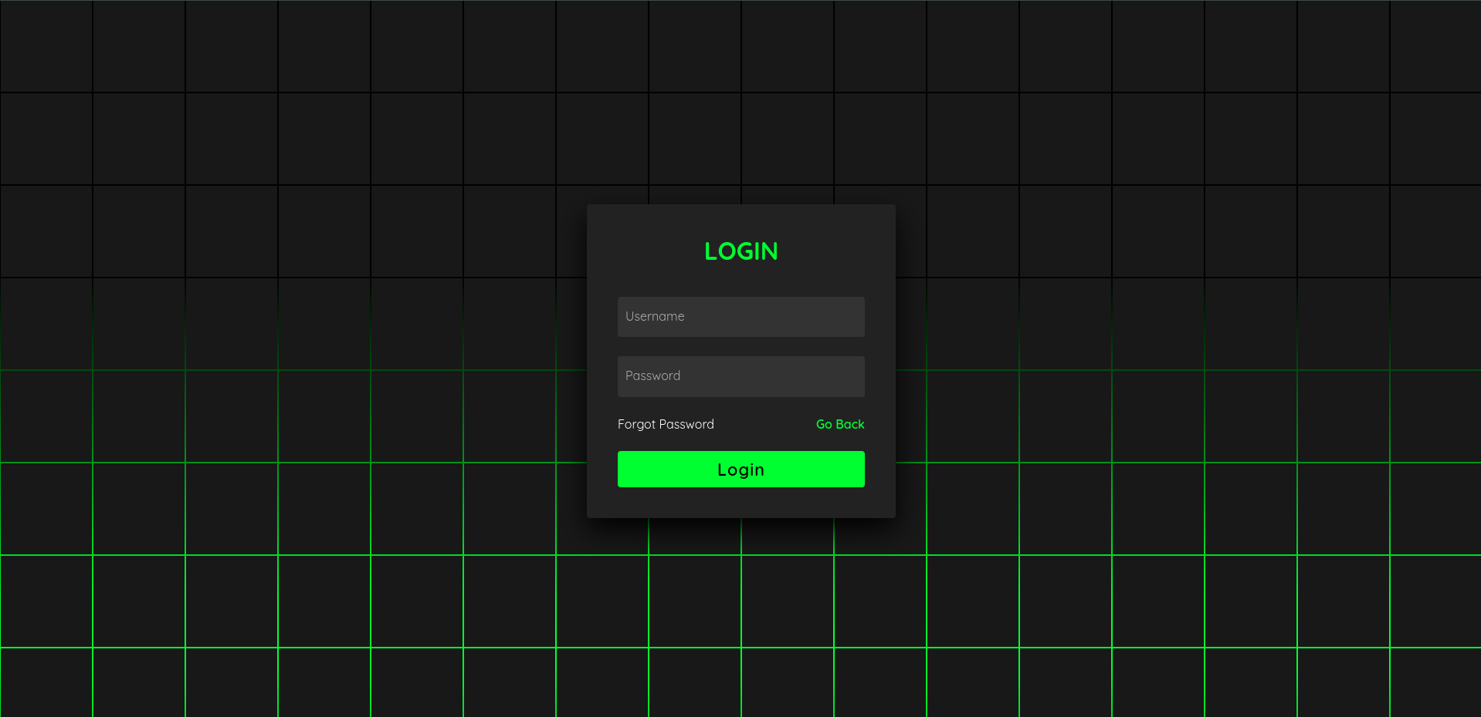

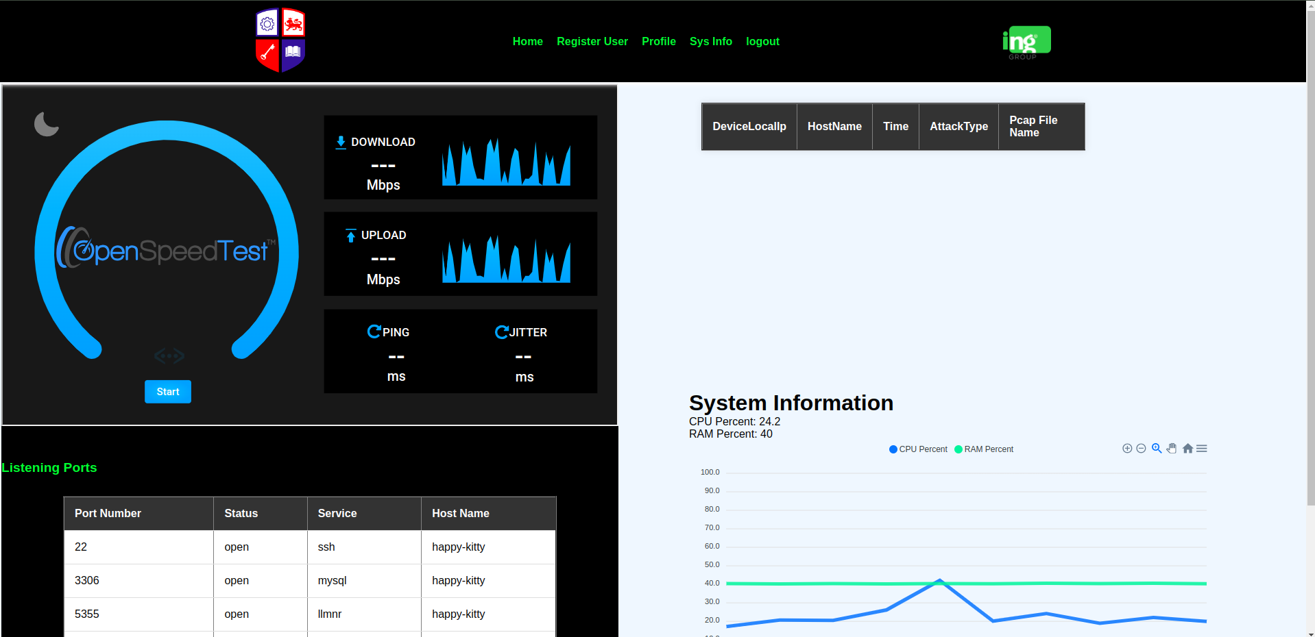

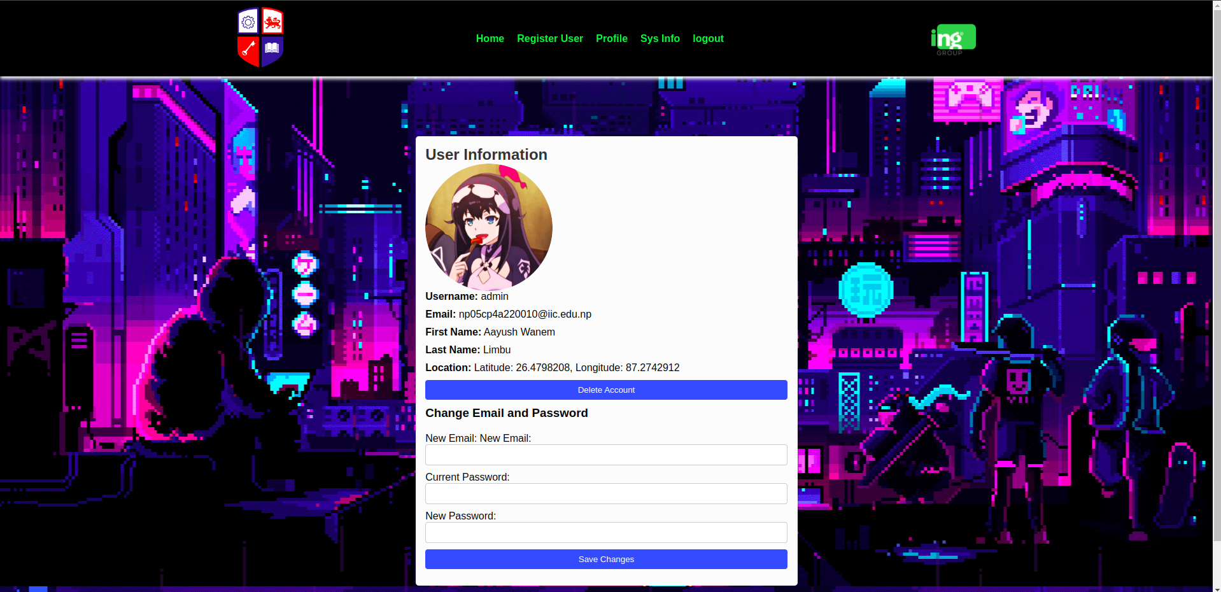

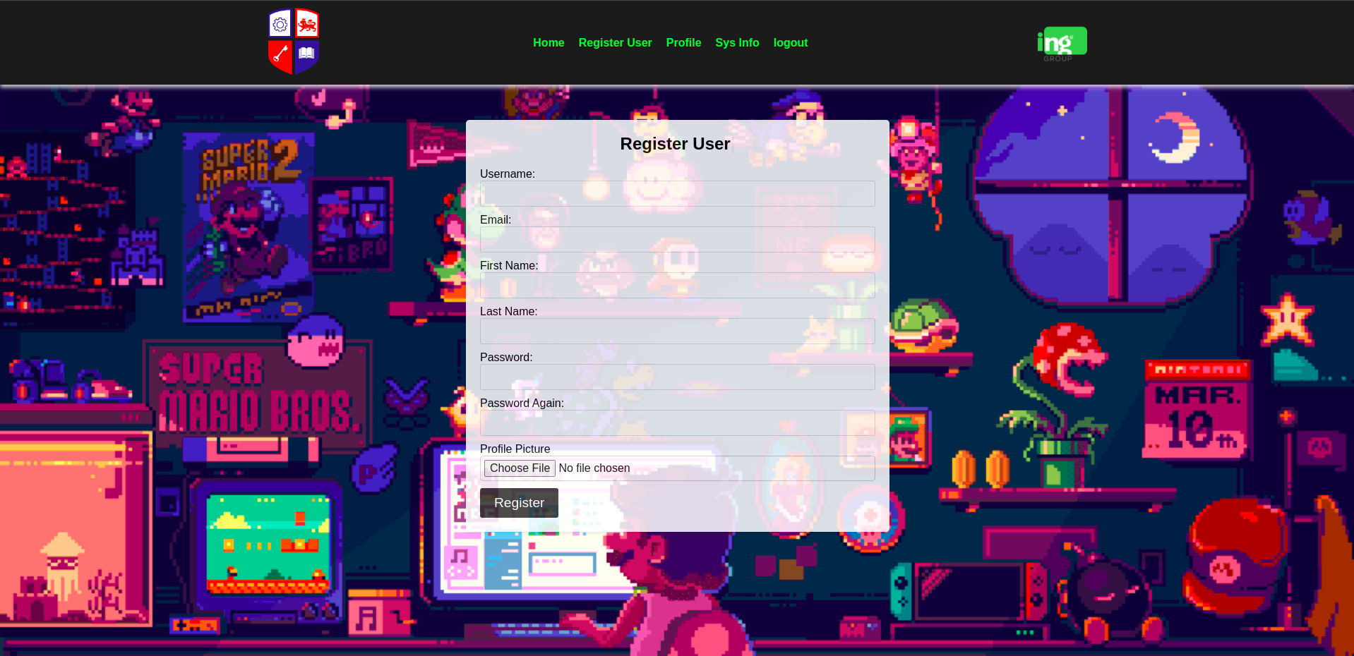

# Testing and Analysis

**Test 1**

|  |  |
| --- | --- |
| **Objective** | To compile and run project. |
| **Action** | Run django project via “**python manage.py runserver”** Command. |
| **Expected Result** | Project will run successfully. |
| **Actual Result** | The project ran successfully. |
| **Conclusion** | The test was successful. |

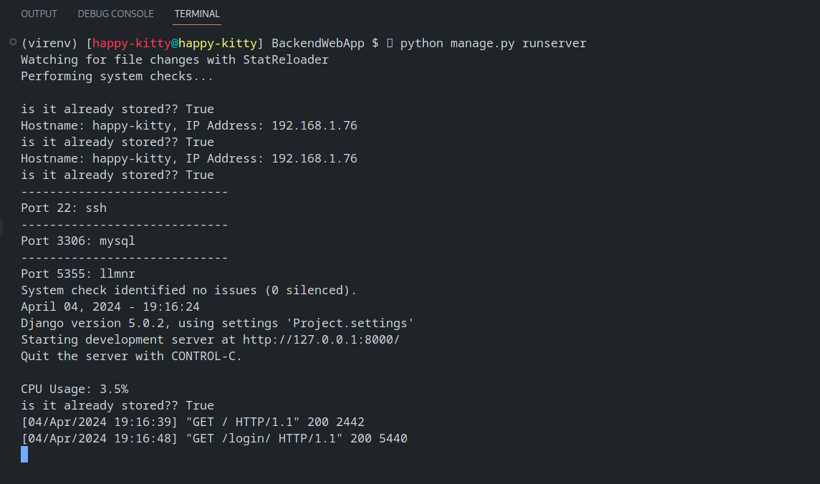

**Test 2**

|  |  |
| --- | --- |
| **Objective** | To login with the correct username and password. |
| **Action** | Enter admin as the username and admin as the password. |
| **Expected result** | The user must be logged in and redirected to the home page. |
| **Actual Result** | The user was logged in and redirected to the home page. |
| **Conclusion** | The test was sucessful. |

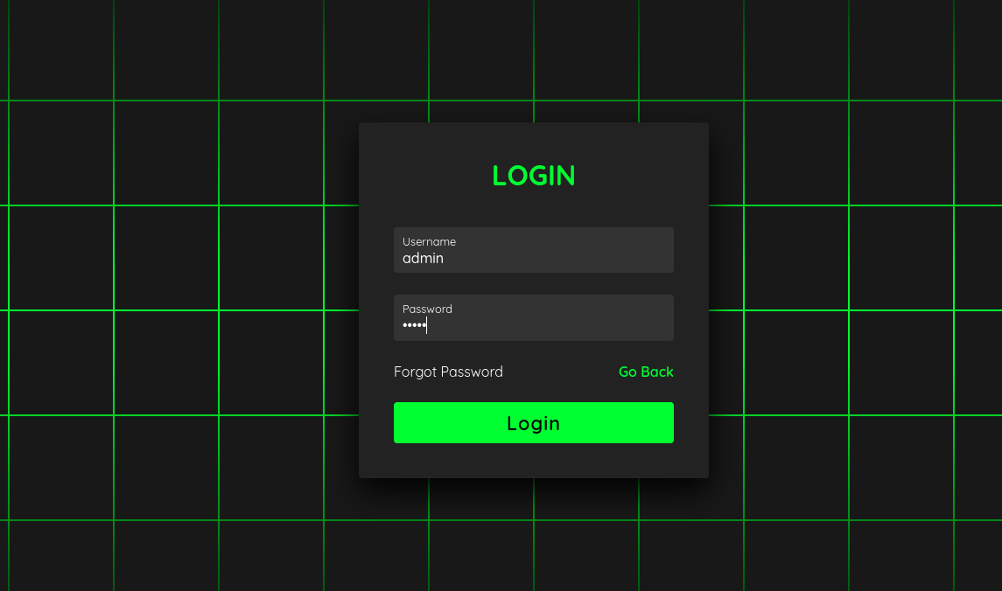

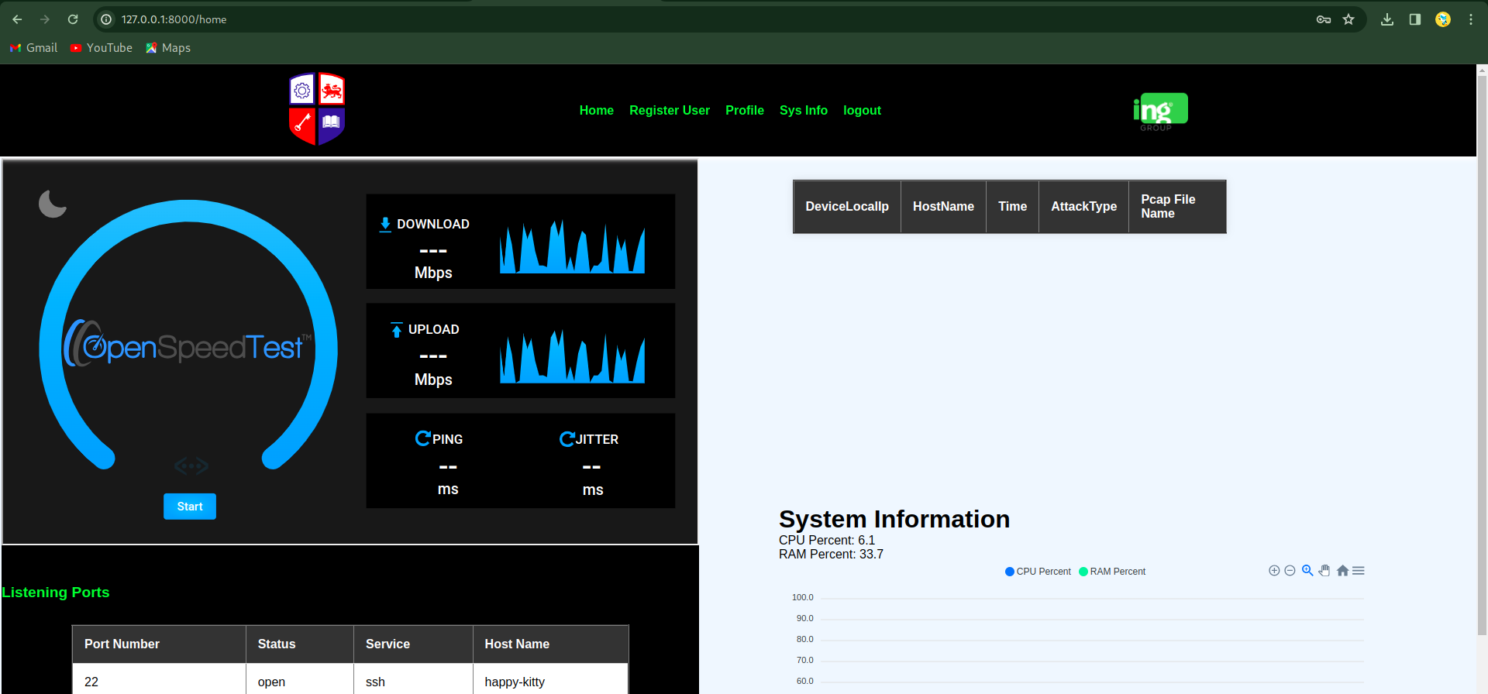

**Test 3**

|  |  |
| --- | --- |
| **Objective** | To create a new user named Aayush |
| **Action** | Entered the following on the user registration page  username = Aayush  password1 = @@yu$#  password2 = @@yu$#  email = [wanemaayush0@gmail.com](mailto:wanemaayush0@gmail.com)  first name = Aayush Wanem  last name = Limbu |
| **Expected Result** | The new account must be created and the mail must be sent to the registered email avout the account creation. |
| **Actual result** | The account was sucessfully created and the email about account creation was sent. |
| **Conclusion** | The test was sucessful |

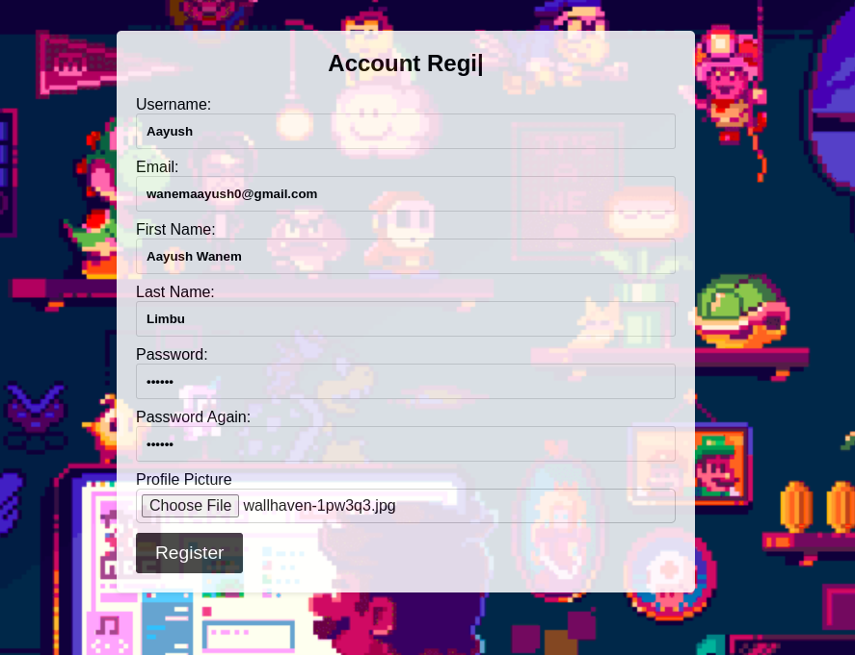

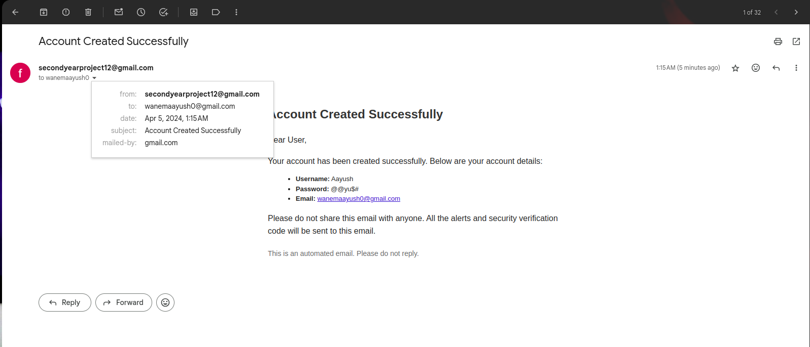

# 

**Test 4**

|  |  |
| --- | --- |
| **Objective** | To update the User’s information  and change password |
| **Action** | Change the email from [wanemaayush0@gmail.com](mailto:wanemaayush0@gmail.com) to [aayushwanemlimbu@gmail.com](mailto:aayushwanemlimbu@gmail.com) and the password to **for$yp12** |
| **Expected result** | The email and the password should be changed. |
| **Actual Result** | The password and email was changed. |
| **Conclusion** | The test was sucessful. |

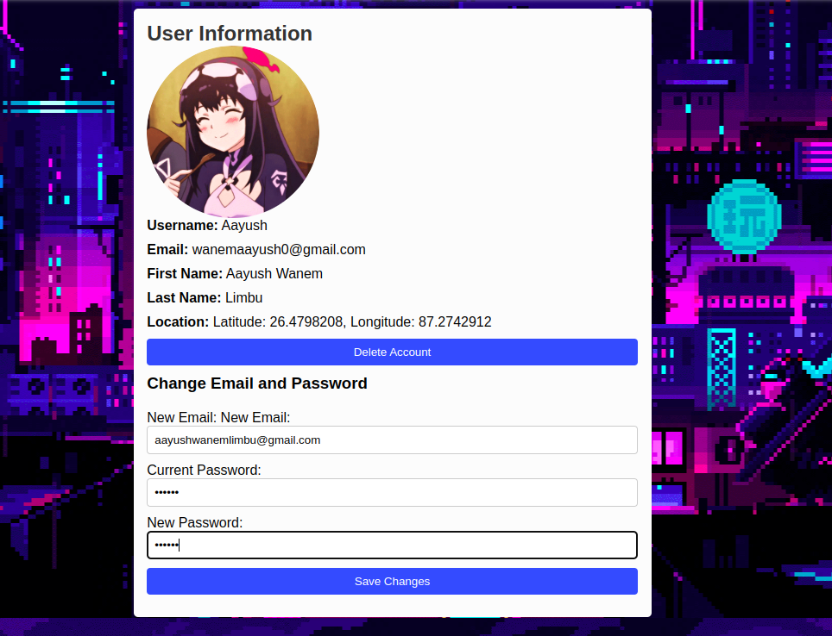

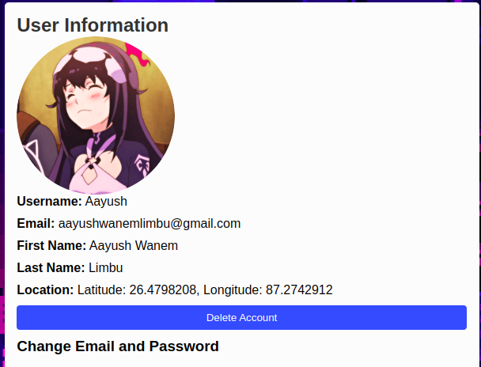

# Conclusion

## 5.2 Legal, Social and Ethical Issues

**Legal Issues:**

Data Privacy: Ensuring compliance with data protection laws (e.g., GDPR, CCPA) when collecting and processing user data is crucial. This includes implementing measures to secure user information and using it only for its intended purpose.

Intellectual Property: Avoiding infringement of patents or copyrights related to intrusion detection technologies is essential. This may involve conducting thorough research to ensure that the system's design and functionality do not violate existing intellectual property rights.

Liability: Clarifying liability in case the system fails to detect or respond to a security breach is important. Establishing clear terms of service and disclaimers can help mitigate legal risks and protect both users and developers.

**Social Issues:**

User Privacy: Balancing the need for intrusion detection with user privacy concerns is key. Providing users with control over their data and transparency about how it is used can help build trust and mitigate privacy risks.

Trust: Building trust with users is crucial. Providing clear and accurate information about the system's capabilities and limitations can help manage expectations and prevent misunderstandings.

Digital Divide: Ensuring that the system is accessible and useful to all users, regardless of their technological literacy, is important. This may involve designing user-friendly interfaces and providing support for users with limited technical knowledge.

**Ethical Issues:**

Bias: Addressing bias in machine learning algorithms is critical. Ensuring that the algorithms used in the system are fair and unbiased requires careful attention to data selection, model training, and validation processes.

Transparency: Providing transparency about how the system works and how decisions are made is essential. This includes explaining the rationale behind intrusion detection alerts and providing users with the ability to understand and challenge these decisions.

Accountability: Establishing mechanisms to hold individuals or organizations accountable for misuse of the system is important. This may involve implementing audit trails and oversight mechanisms to ensure that the system is used ethically and responsibly.

## 5.3 Limitations

The intrusion detection and notification system, despite its potential benefits, may have several limitations that need to be considered:

1. **False Positives and Negatives**: The system may generate false positives (incorrectly identifying benign activities as intrusions) or false negatives (failing to detect actual intrusions), which can impact its effectiveness and user trust.
2. **Performance Impact**: Continuous monitoring and analysis of network traffic can impose a performance overhead on the system, potentially affecting the overall network performance.
3. **Complexity and Maintenance**: Implementing and maintaining the system, especially its machine learning components, may require specialized knowledge and ongoing updates to keep up with evolving threats.
4. **Resource Intensive**: The system may require significant computational resources, particularly for machine learning algorithms, which could limit its scalability and accessibility.
5. **Privacy Concerns**: Collecting and analyzing network traffic data raises privacy concerns, and ensuring compliance with data protection regulations is essential.
6. **Dependency on Data Quality**: The effectiveness of the system relies heavily on the quality and relevance of the data used for training and detection, which may be challenging to obtain in some cases.
7. **Limited Scope**: The system's capabilities may be limited to specific types of attacks or network environments, which may not cover all potential threats.
8. **User Acceptance**: Users may be resistant to adopting new security measures or may not fully understand the system's alerts and recommendations, affecting its overall effectiveness.
9. **Legal and Regulatory Compliance**: Ensuring compliance with legal and regulatory requirements, such as data protection laws, can be challenging and may impose limitations on the system's design and operation.

These limitations highlight the need for careful consideration of the system's design, implementation, and operation to maximize its benefits while mitigating potential drawbacks.

## 5.5 Future Work

Future work for the intrusion detection and notification system could focus on several areas to enhance its capabilities and effectiveness:

1. **Advanced Machine Learning Techniques**: Incorporating more advanced machine learning algorithms, such as deep learning, to improve the system's ability to detect and classify network intrusions accurately.
2. **Real-Time Response Mechanisms**: Implementing real-time response mechanisms to automatically mitigate detected intrusions, such as blocking malicious IP addresses or isolating compromised devices.
3. **Behavioral Analysis**: Enhancing the system's ability to detect anomalies in network behavior by analyzing patterns over time, rather than relying solely on signature-based detection methods.
4. **Integration with Threat Intelligence Feeds**: Integrating with external threat intelligence feeds to enhance the system's ability to detect emerging threats and adapt to evolving attack techniques.
5. **User-Friendly Interfaces**: Improving the system's user interfaces to provide administrators with more intuitive and informative dashboards for monitoring and managing network security.
6. **Scalability and Performance Optimization**: Optimizing the system's performance and scalability to handle larger volumes of network traffic and devices without compromising detection accuracy.
7. **Enhanced Privacy Protection**: Implementing additional measures to protect user privacy, such as data anonymization techniques and strict access controls.
8. **Compliance with Emerging Standards**: Ensuring compliance with emerging cybersecurity standards and regulations to address evolving threats and regulatory requirements.
9. **Collaborative Intrusion Detection**: Implementing collaborative intrusion detection mechanisms to enable sharing of threat intelligence and detection data among different systems and organizations.
10. **Continuous Monitoring and Evaluation**: Conducting regular audits and evaluations of the system to identify areas for improvement and ensure that it remains effective against new and emerging threats.

By focusing on these areas, future work can further enhance the intrusion detection and notification system's capabilities, making it more robust, efficient, and adaptive to the evolving cybersecurity landscape.